**Project Screenshots**

1. Screenshots of Product Inventory Table
   1. 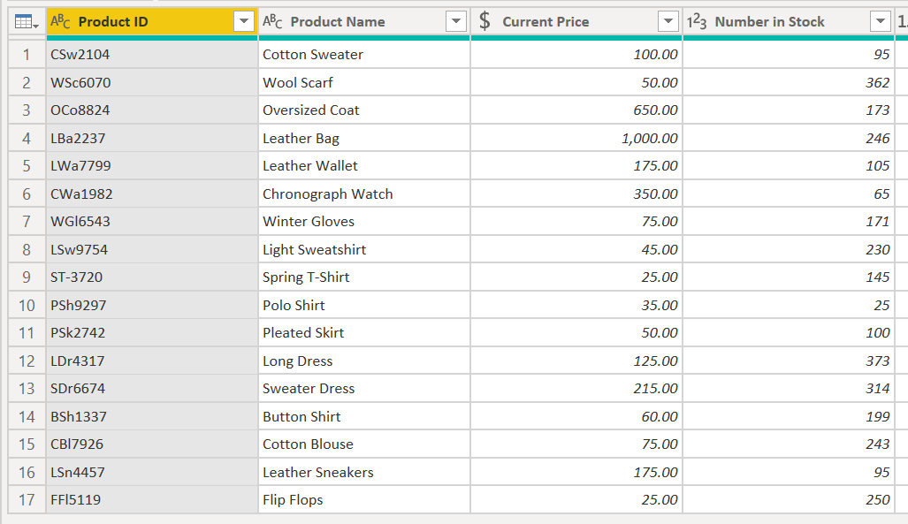Screenshot of first four columns
   2. 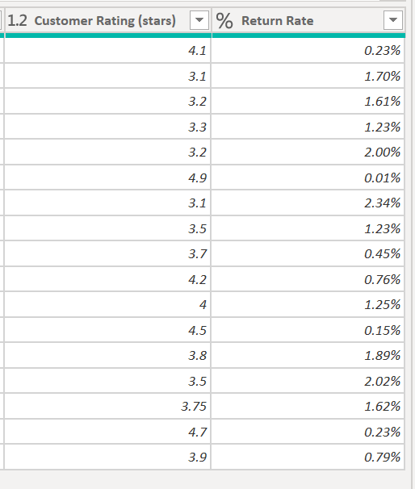Screenshot of last two columns
   3. 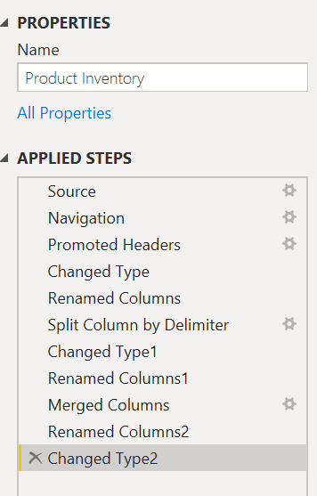Screenshot of applied steps
2. Screenshots of Purchase List Table
   1. 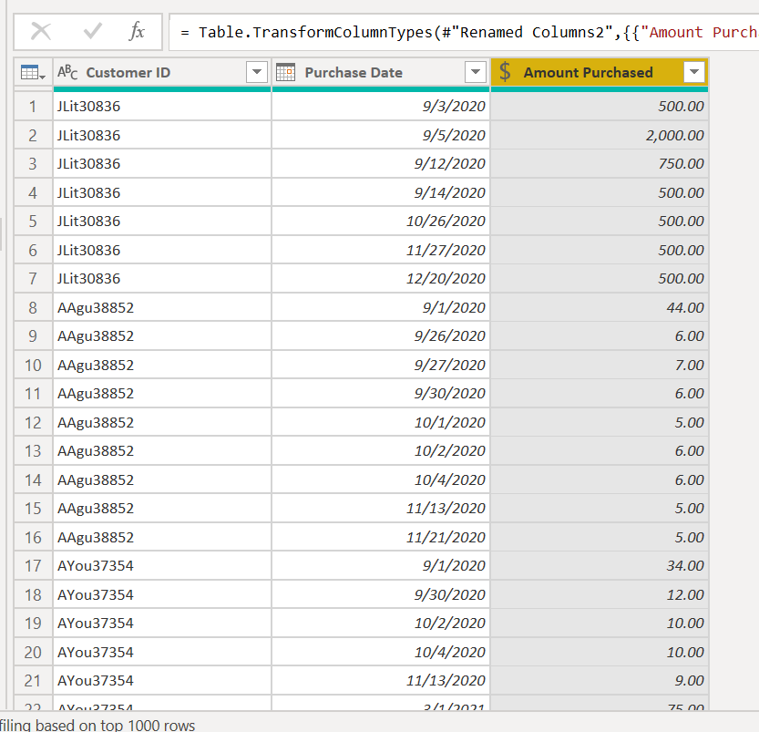Screenshot of final table
   2. 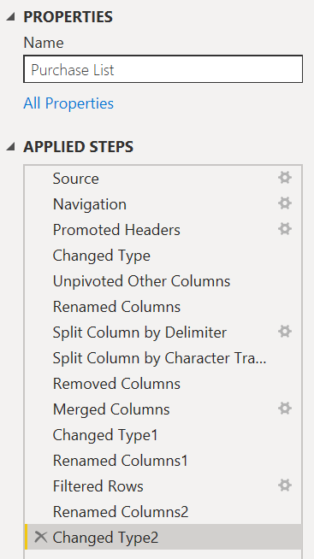Screenshot of applied steps
3. Screenshot of DAX formula – Income category

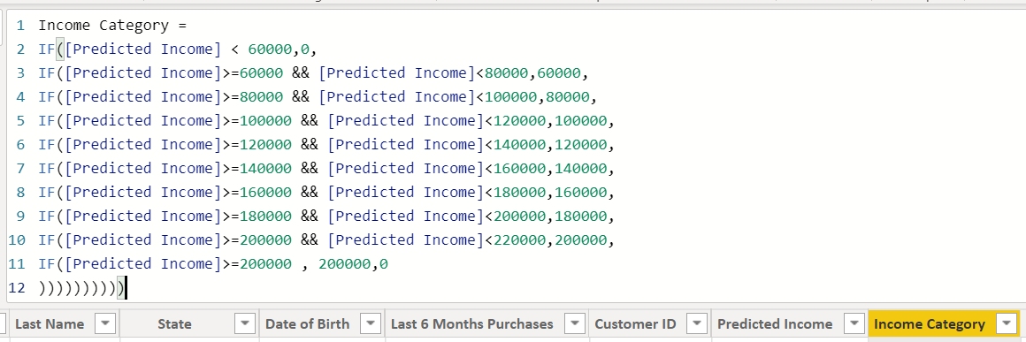

1. 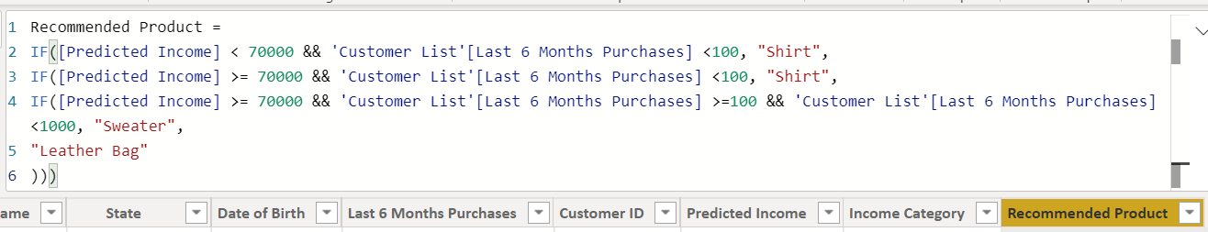Screenshot of DAX formula – Product Recommendation
2. 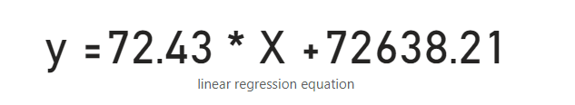Screenshot of the formula used to predict customer incomes based on the linear regression of sales and income
3. 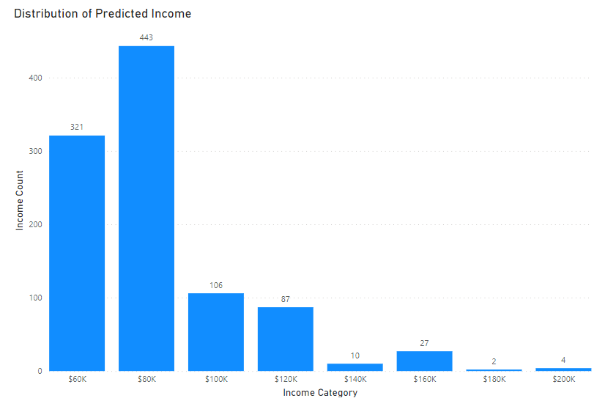Screenshot of histogram – Distribution and shape of predicted income
4. Screenshot of scatterplot and card

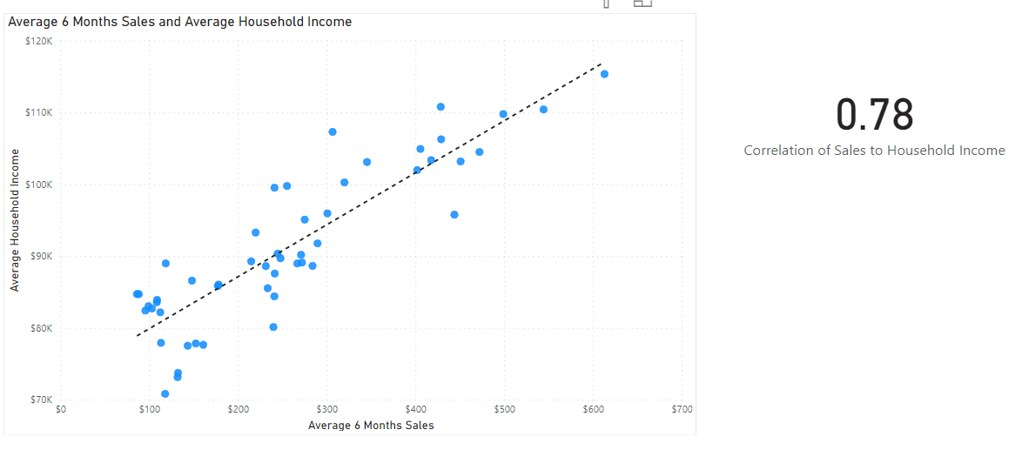

1. 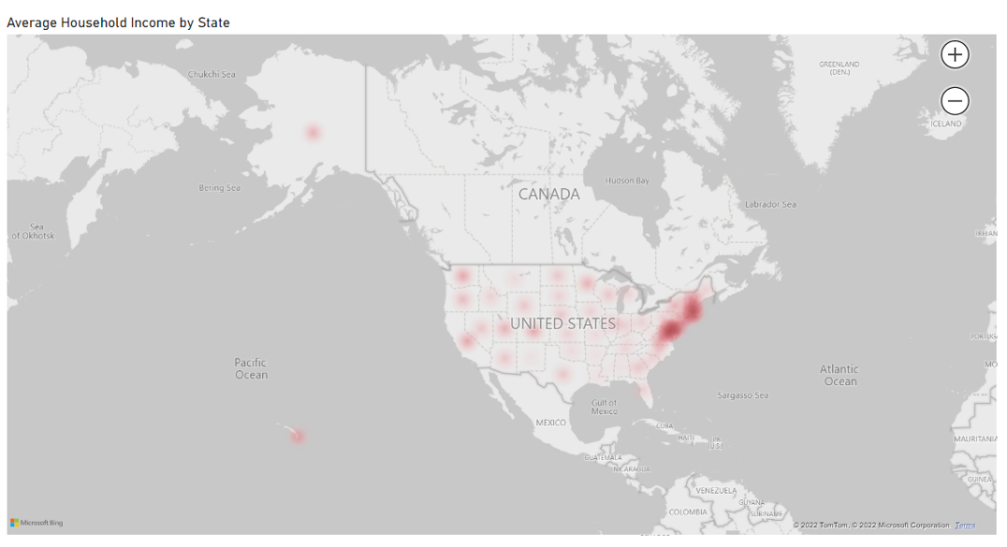Screenshot of the heatmap – Average household income by state
2. Screenshots of cross-filter
   1. 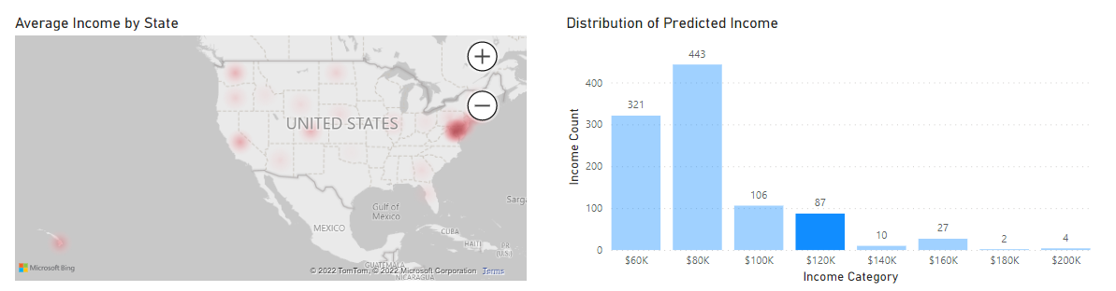Screenshot of cross-filtered histogram and heatmap
   2. 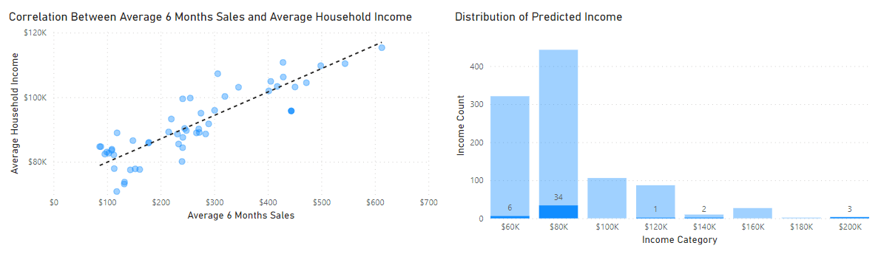Screenshot of cross-filtered scatterplot and histogram
   3. 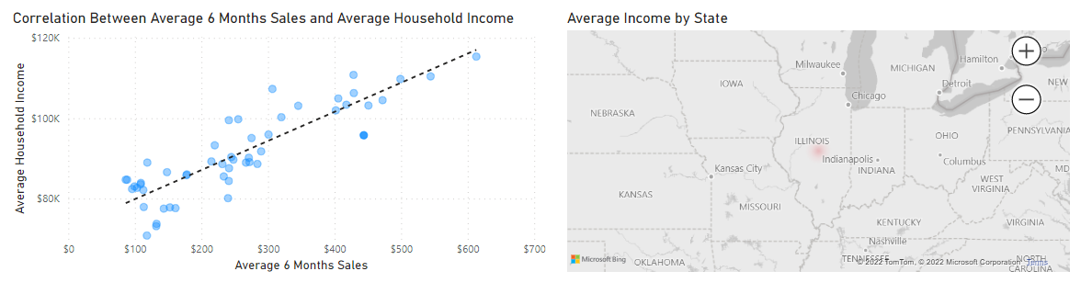Screenshot of cross-filtered scatterplot and heatmap